🧠
RAG Learning Project
Architecture & Pipeline Report
A Retrieval-Augmented Generation system with hybrid retrieval,
multi-stage guardrails, semantic caching, and self-reflection.
Prepared: July 2026

Table of Contents
1. Executive Summary
2. Technology Stack
3. Databases & Storage Layers
4. AI Models & Providers
5. Pipeline Flow: Step-by-Step
5.1 Document Ingestion Pipeline
5.2 Chat Pipeline — Stage-by-Stage
6. External API Summary
7. Latency Breakdown
8. Conclusion

1. Executive Summary
This report documents the architecture of the RAG Learning project, an end-to-end Retrieval-Augmented Generation (RAG) application. The system combines a React frontend with a FastAPI backend, a multi-database storage layer (PostgreSQL, Qdrant, Redis), and a multi-model AI stack (Cohere, Azure OpenAI, and Groq) to answer user questions over an ingested document corpus.
The application is organized around two pipelines: a document Ingestion Pipeline that extracts, chunks, embeds, and indexes source documents, and a Chat Pipeline that guards, routes, retrieves, reranks, generates, reflects on, and caches every user query. The chat pipeline is notable for its depth of guardrails — input validation, toxicity and PII screening, prompt-injection defense, no-context and relevance checks, and post-generation faithfulness, groundedness, and citation verification — alongside a semantic cache that can short-circuit the entire pipeline for repeated queries.

2. Technology Stack
The table below summarizes the frameworks, libraries, and tools used across the frontend, backend, and AI/NLP layers of the application.
Component | Technology
Frontend Framework | React (v19) with Vite
Styling | Tailwind CSS
UI Components / Icons | Lucide React
Markdown Rendering | React Markdown (with remark-gfm)
Backend Framework | FastAPI, served via Uvicorn
Backend Language | Python
Data Validation | Pydantic
Document Processing | PyMuPDF (fitz) and Docling
Caching / State | Redis
Text Chunking | LangChain RecursiveCharacterTextSplitter
Tokenizer | HuggingFace sentence-transformers/all-MiniLM-L6-v2
Hybrid Search | Rank-BM25
Fusion Algorithm | Reciprocal Rank Fusion (RRF)
Evaluation | DeepEval (AnswerRelevancyMetric)
Auth / Environment | python-dotenv

3. Databases & Storage Layers
The project uses a multi-database architecture that separates relational data, vector embeddings, and transient cache state, plus a local file system layer for temporary uploads and analytics.
Store | Purpose
PostgreSQL | Relational store for chat_sessions and chat_messages: session metadata, memory summaries, recent messages, roles, content, citations, and generation stats.
Qdrant | Vector database storing chunked document embeddings and payload metadata (chunk_id, document_id, page, section, source, token_count) for similarity search.
Redis | Semantic cache (semantic_cache) that stores responses keyed by query embedding, returning cached answers for semantically similar queries to cut latency and cost.
Local File System | Temporary storage for uploaded documents under /data, plus manifest.json and analytics.json for tracking and analytics.

3.1 Qdrant Vector Payload
Each vector stored in Qdrant carries the following payload fields: vector (1024-dim float from Cohere), chunk_id, document_id, text, page, section, source, chunk_index, and token_count.

3.2 PostgreSQL Schema

chat_sessions
- id — session UUID (primary key)
- title — auto-set from the first query
- collection_id — associated Qdrant collection
- memory_summary — LLM-compressed conversation history
- recent_messages — JSON array of the last 7 Q&A turns
- created_at / updated_at — timestamps

chat_messages
- id — message UUID (primary key)
- session_id — foreign key to chat_sessions
- role — user or assistant
- content — message text
- citations — JSON array of source chunk references
- stats — JSON containing latency, confidence, and model metadata

3.3 Redis Semantic Cache
Key Pattern | Purpose
semantic:response_index | In-memory index mapping cache_key to {question, embedding} for cosine-similarity lookups.
cache:ans:<hash> | Serialized JSON with the full generated response, citations, and stats.

4. AI Models & Providers
The application routes each task to the model best suited for it, balancing quality (Azure OpenAI for generation) against speed and cost (Groq for utility tasks).
Role | Model | Purpose
Embeddings | Cohere embed-english-v3.0 | 1024-dimensional dense vectors for ingestion and query embedding.
Reranking | Cohere rerank-english-v3.0 | Reorders fused retrieval results by semantic relevance.
Generation (Primary LLM) | Azure OpenAI gpt-4.1 (configurable) | Streams the final answer using filtered context and memory.
Utility / Fast LLM | Groq llama-3.1-8b-instant | Query rewriting, intent routing, toxicity refusals, general-knowledge answers.
Reflection | Groq (via Reflector service) | Fast self-critique of the generated answer before it is finalized.
Alternative Providers | Google GenAI, local LLaMA (llama-cpp-python) | Supported as configurable swap-ins for the primary/utility LLMs.

5. Pipeline Flow: Step-by-Step
The architecture is built around two pipelines: a Document Ingestion Pipeline (app.py) that prepares source documents for retrieval, and a Chat Pipeline (runner.py) that governs every user query from arrival to final response.

5.1 Document Ingestion Pipeline
- Extraction — Documents are parsed with PyMuPDF (fast/default) or Docling (structured/layout-aware) to produce raw text pages.
- Cleaning & Chunking — Extracted text is normalized and split into chunks using LangChain's RecursiveCharacterTextSplitter (chunk_size=500, overlap=100), then token-counted with a HuggingFace tokenizer.
- Embedding Generation — Chunks are sent to Cohere embed-english-v3.0 to generate 1024-dimensional dense vectors.
- Vector Storage — Chunks and embeddings are indexed in Qdrant.
- Sparse Indexing — A BM25 index is built and saved to disk (bm25_index.pkl) to support hybrid search.
An experimental knowledge-graph extraction component using entity resolvers is also part of the architecture, though not on the primary path.

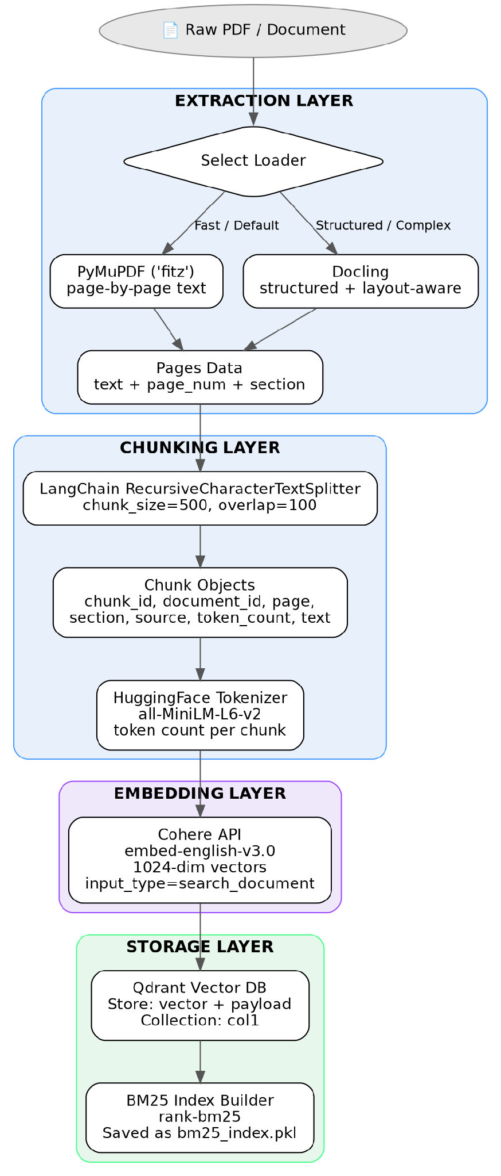
Figure 1 — Document Ingestion Pipeline

5.2 Chat Pipeline — Stage-by-Stage

Stage 1 — Pre-Retrieval Guards
- InputGuard — checks basic query validity (empty, too short, spam).
- ToxicityGuard — scans for toxic/harmful language; a Groq LLM generates a polite refusal if triggered.
- PIIGuard — prevents personally identifiable information from entering the system.
- PromptInjectionGuard — defends against adversarial attempts to override system instructions.

Stage 2 — Semantic Cache Check
The query is embedded via Cohere and compared against cached queries by cosine similarity. A similarity of 0.92 or higher returns the cached response immediately; otherwise the pipeline continues.

Stage 3 — Query Routing & Classification
classify_query analyzes intent via a Groq LLM. Chit-chat gets a fixed polite reply, general-knowledge questions get a direct Groq answer, and domain queries proceed to retrieval — each shortcut saves the cost and latency of a full RAG pass.

Stage 4 — Query Rewrite (Memory)
A memory_context is built from the last 7 messages plus a running summary loaded from PostgreSQL. The raw query is then rewritten by Groq to resolve coreferences, e.g. turning "What is its purpose?" into a standalone question naming the topic.

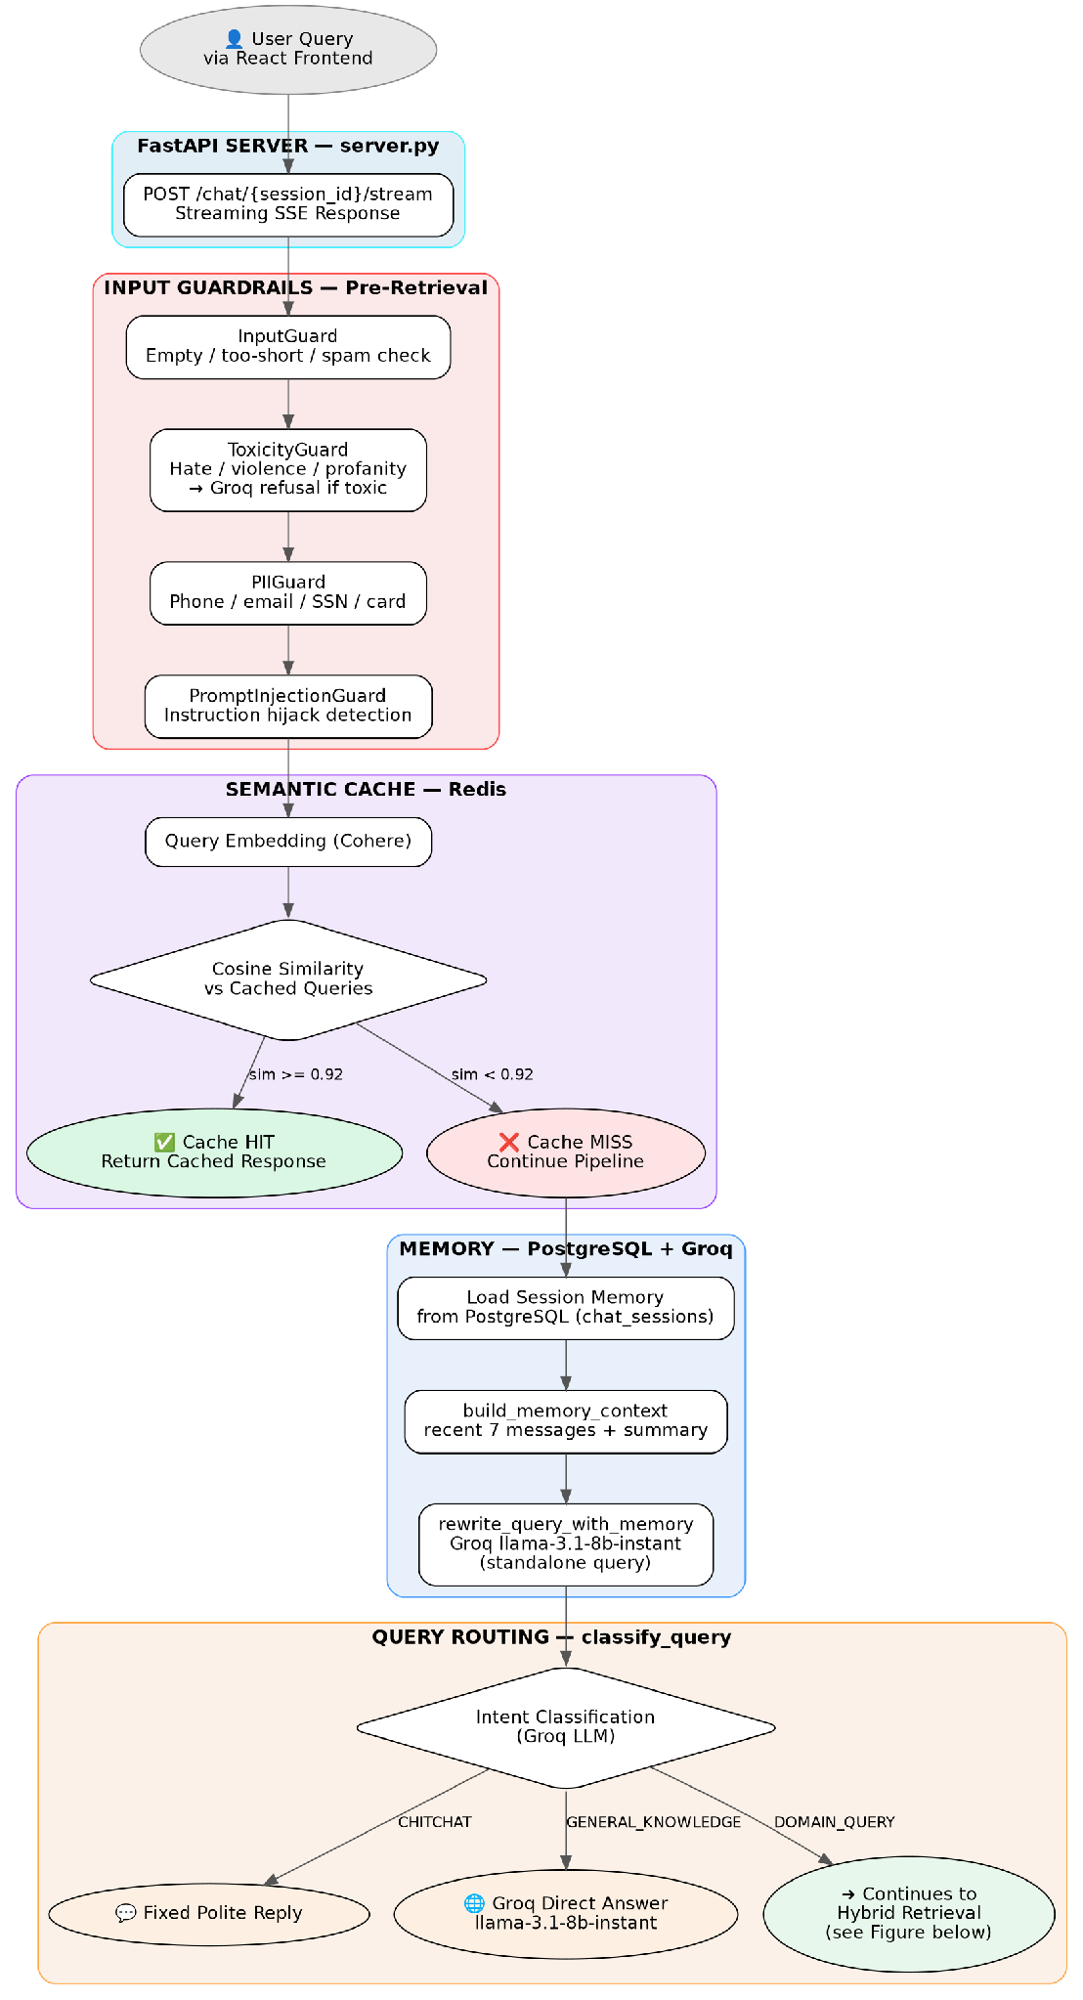
Figure 2 — Pre-Retrieval: Input Guards, Semantic Cache, Memory & Query Routing

Stage 5 — Hybrid Retrieval
The rewritten query is embedded and searched against Qdrant (dense, top 30) and BM25 (sparse, top 30) in parallel. Results are combined with Reciprocal Rank Fusion (RRF), then reranked by Cohere's rerank-english-v3.0 down to the top 10 chunks.

Stage 6 — Reranking & Context Guards
- NoContextGuard — halts and informs the user if all scores fall below a 0.005 threshold.
- RelevanceGuard — filters out chunks scoring below 0.008.
- ConfidenceCalculator — derives a confidence score from the surviving chunk distribution.

Stage 7 — Generation
The GenerationService assembles a prompt from the system instructions, memory context, filtered chunks, and rewritten query, then streams a response from Azure OpenAI gpt-4.1 (max_context_tokens=6000) via server-sent events.

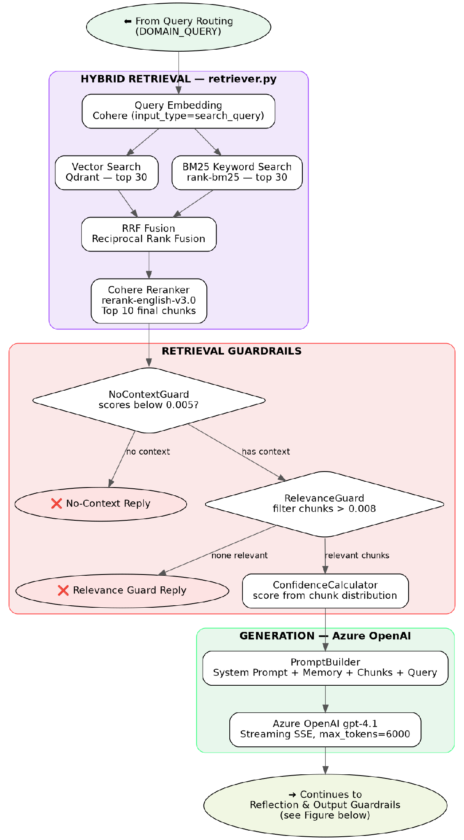
Figure 3 — Hybrid Retrieval, Retrieval Guardrails & Generation

Stage 8 — Reflection
The Reflector runs a self-critique of the generated answer via Groq, evaluating it against the original query and retrieved context, and can revise the answer if it fails critique.

Stage 9 — Post-Generation Guards
- OutputFormattingGuard — verifies the response meets formatting requirements.
- FaithfulnessGuard — checks whether the answer hallucinates information not present in the context.
- GroundednessGuard — ensures specific claims are strictly grounded in source text.
- CitationGuard — validates that citations exist and map correctly to source chunks.

Stage 10 — Finalization, Persistence & Cache Update
The user message and assistant answer (with citations and stats) are saved to chat_messages. compact_memory summarizes older turns into memory_summary via Azure OpenAI, updating chat_sessions. The final answer is stored in Redis and the semantic index is updated so future similar queries hit the cache.

Stage 11 — Evaluation
A background thread (non-blocking) runs DeepEval's AnswerRelevancyMetric, backed by Groq, and stores results in memory for retrieval via GET /eval/{message_id}.

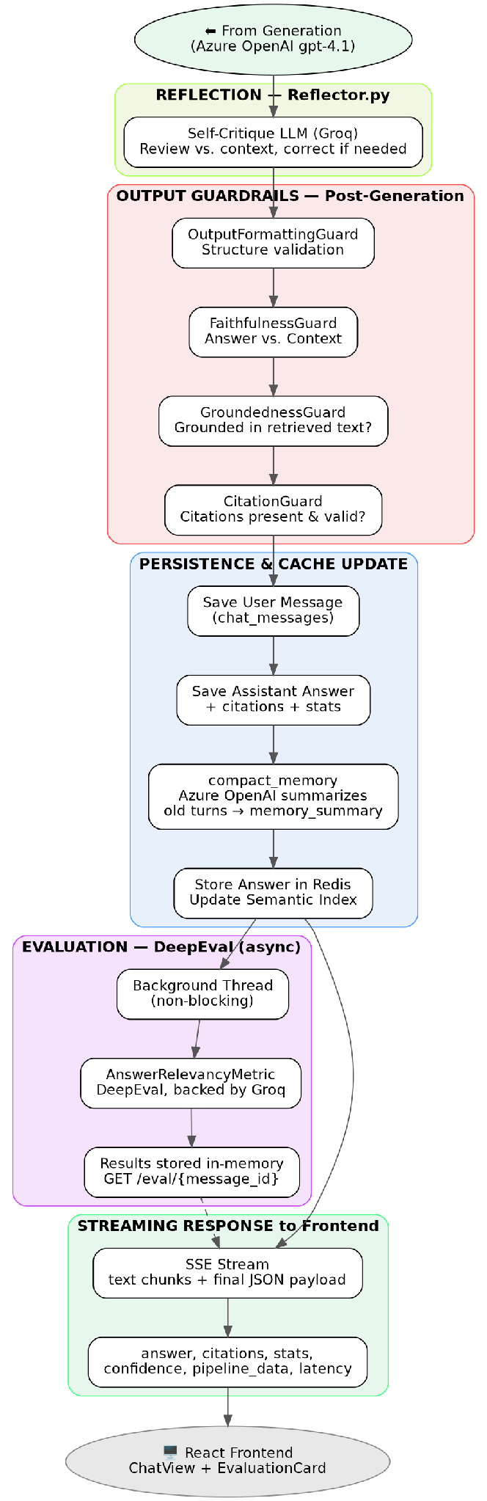
Figure 4 — Reflection, Post-Generation Guardrails, Persistence, Evaluation & Response

6. External API Summary
API | Provider | Usage
embed-english-v3.0 | Cohere | Ingestion embeddings and query embeddings, including cache similarity checks.
rerank-english-v3.0 | Cohere | Final reranking of fused vector + BM25 results.
gpt-4.1 (streaming) | Azure OpenAI | Primary answer generation and memory summarization.
llama-3.1-8b-instant | Groq | Query rewrite, chitchat handling, general knowledge, reflection, evaluation.
DeepEval framework | Local / Groq | Answer relevancy evaluation, run asynchronously post-generation.

7. Latency Breakdown (Tracked per Request)
Each request tracks per-stage latency for observability. On a cache miss, the pipeline totals roughly 3–5 seconds end-to-end; on a cache hit, the response returns in under 200 ms.
Stage | Typical Latency | Notes
Cache check | ~100 ms | Query embedding + Redis cosine similarity
Classification | ~50 ms | Groq intent classification
Query rewrite | ~200 ms | Groq memory-aware rewrite
Query embedding | ~100 ms | Cohere embed query
Vector search | ~50 ms | Qdrant ANN search
BM25 search | ~10 ms | In-memory keyword search
RRF fusion | ~1 ms | Pure Python rank fusion
Reranking | ~300 ms | Cohere rerank
Generation | ~1–3 s | Azure OpenAI streaming
Reflection | ~500 ms | Self-critique LLM
Faithfulness check | ~200 ms | LLM-based check
Groundedness check | ~200 ms | LLM-based check

TOTAL (cache miss): ≈ 3–5 seconds end-to-end. TOTAL (cache hit): < 200 ms end-to-end.

8. Conclusion
The RAG Learning project implements a production-oriented RAG architecture: hybrid dense/sparse retrieval fused with RRF and refined by a cross-encoder reranker, layered guardrails on both the input and output paths, memory-aware query rewriting, self-reflective answer correction, and a semantic cache that trades a small amount of staleness for a large latency and cost reduction on repeated queries. The multi-database design cleanly separates relational, vector, and cache concerns, while routing tasks across Cohere, Azure OpenAI, and Groq balances answer quality against speed and cost.

